**Assignment-9**

**(Dheeraj Tiwari)**

1. Perform an experiment to rotate servo motor from 0 to 180 deg and vice-versa.

Ans :

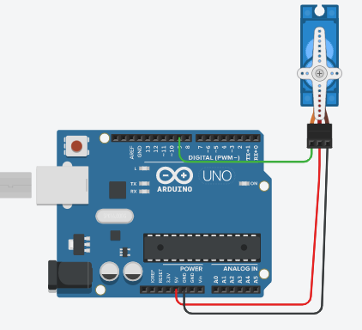

#include <Servo.h>

int pos = 0;

Servo servo_9;

void setup()

{ servo_9.attach(9);

}

void loop()

{ // sweep the servo from 0 to 180 degrees in steps

// of 1 degrees

for (pos = 0; pos <= 180; pos += 1) {

// tell servo to go to position in variable 'pos'

servo_9.write(pos);

// wait 15 ms for servo to reach the position

delay(15); // Wait for 15 millisecond(s)

}

for (pos = 180; pos >= 0; pos -= 1) {

// tell servo to go to position in variable 'pos'

servo_9.write(pos);

// wait 15 ms for servo to reach the position

delay(15); // Wait for 15 millisecond(s)

}}

1. What is a Relay Module? How does the Relay works?

Ans: A Relay is an electromechanical switch, operated by passing current through a coil of wire wound around a steel core, which acts as an electromagnet, pulling the switch contact down to make or break a circuit.

**Working of Relay:**

A small current is passed though the coil which generates a magnetic field. This magnetic field pulls the armature down towards the coil. At the end of the armature is a contact. When

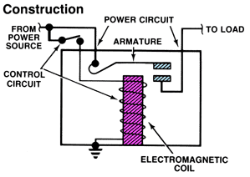

the armature moves its contact touches the contact of the controlled circuit. This creates a closed circuit.

1. Perform an experiment to Interface Servo motor with Arduino and that we have added a potentiometer for position control. The Arduino will read the voltage on the middle pin of the potentiometer and adjust the position of the servo motor shaft.

Ans :

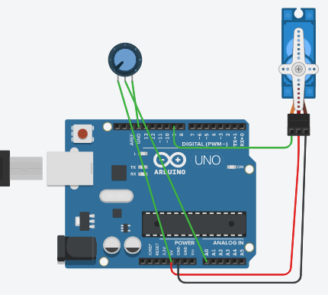

#include <Servo.h>

Servo servo;

int angle = 0;

int p = A0;

void setup()

{

servo.attach(9);

}

void loop()

{

angle = analogRead(p);

angle = map(angle, 0, 1023, 0, 180);

servo.write(angle);

delay(5);

}

4.What is a Servo motor? How does the servo motor works?

Ans :

* A servo is a motor that you can position at any angle very accurately.
* Servos have a limited servo range; most servos have a range of 180 degrees, some have a range of 90, 120, 150, or 210 . Servos are very powerful for their sizes.
* There exist servos that provide a torque of 4kg-cm from a 50 gram servo
* Servos have a rather large torque for their size and run on a relatively low voltage (4.5 – 6 Volts ).
* There are several types of servos in terms of driving like the AC servo motors used for industries. Now we explains the only DC servo motors.

### **Working principle of Servo Motors:**

**A servo consists of a Motor (DC or AC), a potentiometer, gear assembly and a controlling circuit. First of all we use** gear assembly to reduce RPM and to increase torque of **motor. Say at initial position of servo motor shaft, the position of the potentiometer knob is such that there is no electrical signal generated at the output port of the potentiometer. Now an electrical signal is given to another input terminal of the error detector amplifier. Now difference between these two signals, one comes from potentiometer and another comes from other source, will be processed in feedback mechanism and output will be provided in term of error signal. This error signal acts as the input for motor and motor starts rotating. Now motor shaft is connected with potentiometer and as motor rotates so the potentiometer and it will generate a signal. So as the potentiometer’s angular position changes, its output feedback signal changes. After sometime the position of potentiometer reaches at a position that the output of potentiometer is same as external signal provided. At this condition, there will be no output signal from the amplifier to the motor input as there is no difference between external applied signal and the signal generated at potentiometer, and in this situation motor stops rotating**.